PRINCETON-READY RESEARCH PAPER

EterX-Agent: A Local-First, Multi-Interface Runtime for Tool-Orchestrated AI Agents
A review-ready systems paper with a one-page executive summary built into the front for fast admissions and technical review.
Author | Harshil Soni
Project | EterX-Agent
Prepared | 2026-05-19
Document role | Research evidence for application review and technical evaluation

Executive Research Summary (One-page fast review)
Central idea
The project is strongest when read as independent systems work: it shows how practical AI agents fail around continuity, memory, traceability, tools, browser state, and runtime resources, then documents the architecture built to address those failures.

Question | Answer for a fast reviewer
What is EterX-Agent? | A local-first AI-agent runtime connecting web, desktop, Telegram, and voice interfaces to one persistent tool-using execution engine.
Why does it matter? | Most wrapper-style agents fail when context is lost, tools repeat, browser state changes, keys collide, or old memory contaminates a new request.
What did I build? | Per-chat execution, scoped Memory V2, typed tools, browser control, trace persistence, sub-agents, API-key leasing, and artifact workflows.
What is original here? | The novelty is the implementation layer: continuity, scoped memory, traceability, multi-interface runtime behavior, and model-key resource management.
What did I learn? | Reliable AI agents are systems problems. The model matters, but isolation, recovery, observability, constrained memory, and honest evaluation matter just as much.
Strongest technical signals
- Per-chat execution keeps long tasks recoverable after refreshes and makes cancellation scoped rather than global.
- Memory V2 separates session facts, project facts, credentials, artifacts, errors, and self-improvement notes so memory helps without silently taking over the prompt.
- API-key leasing treats model capacity as a runtime resource, reducing collisions between the main chat and background sub-agents.
- The evaluation plan is intentionally honest: the paper presents a serious implemented system and defines the benchmark work needed next, rather than claiming unmeasured superiority.

Contents
Abstract
Introduction
Background and Related Work
Agent Components
Reasoning and Acting
Tool Use
Multi-Agent Coordination
Memory, Reflection, and Skills
Evaluation of LLM Agents
Repository and System Map
EterX-Agent Architecture
Per-Chat Agent Registry
Orchestrator
Model Client and Tool Loop
Tool Registry
Persistent Memory and Session Continuity
Parallel Sub-Agents
Browser and Desktop Automation
User Interfaces
Installer, CLI, and Operational Layer

Original Contributions
The project does not claim novelty from using planning, memory, tools, or multiple agents. Those are common agent categories. The differentiator is the implementation layer that makes those ideas work together in a local runtime: continuity, scoped memory, traceability, multi-interface behavior, and API-key leasing.
Security, Privacy, and Safety Considerations
Evaluation Plan
The evaluation plan is included to show what would make this architecture an empirical research result. Until those tests are run, the paper should be read as a system implementation and evaluation proposal, not as completed benchmark proof.
Discussion
The most important lesson from EterX-Agent is that useful agents are systems, not just prompts. A strong model can still fail if the runtime loses state, hides tool outputs, repeats actions, mixes memories, or cannot recover after disconnection. The strongest engineering signal in this project is the work around continuity, isolation, traceability, and recovery. That is also why the paper should be read as an architecture report with a clear evaluation path, not as a claim of completed empirical proof.
The system also shows a central design tradeoff. More tools make an agent more capable, but they also increase risk. Memory improves continuity, but stale memory can corrupt new tasks. Parallel agents improve throughput, but only when isolated and resource-managed. EterX-Agent is strongest where it makes those tradeoffs visible in code.

Abstract
LLM agents often look capable in short demonstrations but fail in practical settings when state is lost, tools repeat, browser context changes, memory becomes stale, or long-running work becomes invisible. EterX-Agent studies that reliability problem through implementation. It is a local-first AI-agent runtime with web, desktop, Telegram, and voice interfaces; persistent memory; browser automation; sub-agents; typed tools; trace persistence; and API-key leasing. The contribution is not a new model or a completed benchmark result. The contribution is an implementation layer for agent reliability: continuity, scoped memory, traceability, multi-interface runtime behavior, and resource isolation. This paper documents the system architecture, identifies project-specific contributions, gives concrete failure examples, and defines the evaluation work needed next.
Keywords: AI agents, tool use, ReAct, memory systems, local-first AI, browser automation, multi-agent execution, agent reliability.

Introduction
Why this problem matters
In practical AI systems, failure often comes from the runtime around the model: lost state, unsafe memory, repeated tools, browser drift, file confusion, key contention, and weak observability. EterX-Agent was built to study those failures directly.

Modern AI agents are no longer single-turn chatbots. They plan, call tools, browse websites, write files, inspect code, remember preferences, and coordinate work across multiple steps. Yet the central challenge is not simply giving a model more tools. The harder problem is making those tools reliable when a user leaves the page, returns later, uploads files, switches interfaces, or asks the agent to continue work from a previous session.
Through building EterX-Agent, I found that the important engineering questions appear at the boundaries between components. Memory helps only if it is scoped. Browser automation works only if actions are serialized against the current page state. Sub-agents are useful only if their work is isolated and collectable. Long-running work feels trustworthy only when traces survive refreshes and failures are visible.
The project is implemented as a TypeScript and JavaScript application using Next.js, Electron, React, and a Node.js backend. It includes a custom model tool loop, a large typed tool registry, persistent memory stores, browser automation, Telegram integration, live voice support, setup utilities, and a UI focused on trace visibility. The repository analysis found 134 TypeScript files, 27 TSX files, 19 JavaScript files, 78 markdown files, and approximately 85,268 non-dependency lines.
This paper answers three questions:
- How can an LLM agent preserve long-horizon task continuity without letting stale memory dominate new requests?
- How can one runtime coordinate model calls, local tools, browser automation, documents, communication channels, and parallel sub-agents?
- Which parts of EterX-Agent follow common AI-agent patterns, and which parts are project-specific implementation contributions?
The paper makes four contributions:
- It documents EterX-Agent as a runtime for real tool execution rather than a prompt-only wrapper.
- It separates standard agent ideas from implementation-specific engineering contributions.
- It adds concrete failure cases that explain why the architecture was designed this way.
- It proposes a benchmark plan without claiming results that have not yet been measured.

Background and Related Work

Agent Components
Current AI-agent systems commonly combine an LLM core, memory, planning, tool routing, environment interaction, and sometimes reflective evaluators. EterX-Agent uses these familiar components, but its emphasis is operational: keeping work alive, visible, scoped, and recoverable across local interfaces.

Reasoning and Acting
The model loop follows a ReAct-style pattern: the model receives context, chooses a tool, observes the result, and continues. EterX-Agent adds runtime mechanics around that loop, including trace buffering, file previews, duplicate-call blocking, per-chat cancellation, and recovery from transient model or rate-limit failures.

Tool Use
Tool-learning research shows that models can learn when and how to call external tools. EterX-Agent does not train a model. It implements a typed tool registry with schemas and execution functions for shell commands, files, code, web search, browser control, document generation, charts, communication tools, scheduling, and memory.

Multi-Agent Coordination
Multi-agent frameworks often focus on agent-to-agent conversation. EterX-Agent uses a more practical fire-and-forget model: the main agent assigns background sub-agents independent tasks, continues its own work, and later collects results from a local queue.

Memory, Reflection, and Skills
Memory-based agents show that prior observations and reflection can improve continuity. EterX-Agent treats memory as a safety-sensitive subsystem. It separates raw events, sessions, user facts, project facts, credentials, errors, artifacts, and self-improvement overlays rather than storing everything as one undifferentiated memory stream.

Evaluation of LLM Agents
Agent evaluation must measure sequences of actions, not just final text. The project currently has strong instrumentation but no controlled benchmark report, so this paper presents architecture analysis and an evaluation plan rather than claiming empirical superiority.

Repository and System Map
The most important project areas are listed first because they show where the technical depth is concentrated.
Area | Main paths | Role
Agent runtime | src/lib/agent/orchestrator.ts, src/lib/agent/gemini.ts, src/lib/agent/agent-registry.ts | Executes requests, routes models, streams traces, persists tasks, coordinates tool calls.
Tool system | src/lib/agent/tools/** | Defines typed tools for shell, workspace, browser, research, automation, communication, memory, and artifacts.
Memory and continuity | src/lib/agent/memory/**, src/lib/agent/session.ts, src/lib/agent/task-store.ts | Stores project memory, scoped Memory V2 records, session state, file records, and task traces.
Parallel agents | src/lib/agent/roles/sub_agent.ts, spawn_sub_agent.ts, api-key-pool.ts | Spawns background sub-agents, isolates cancellation, leases API keys, and collects results.
Interfaces | src/app/page.tsx, electron/main.js, telegram-bot.ts, src/lib/live/gemini-live.ts | Provides web, desktop, Telegram, and live voice access to the same runtime.
Table 1. Major repository areas and their architectural roles.
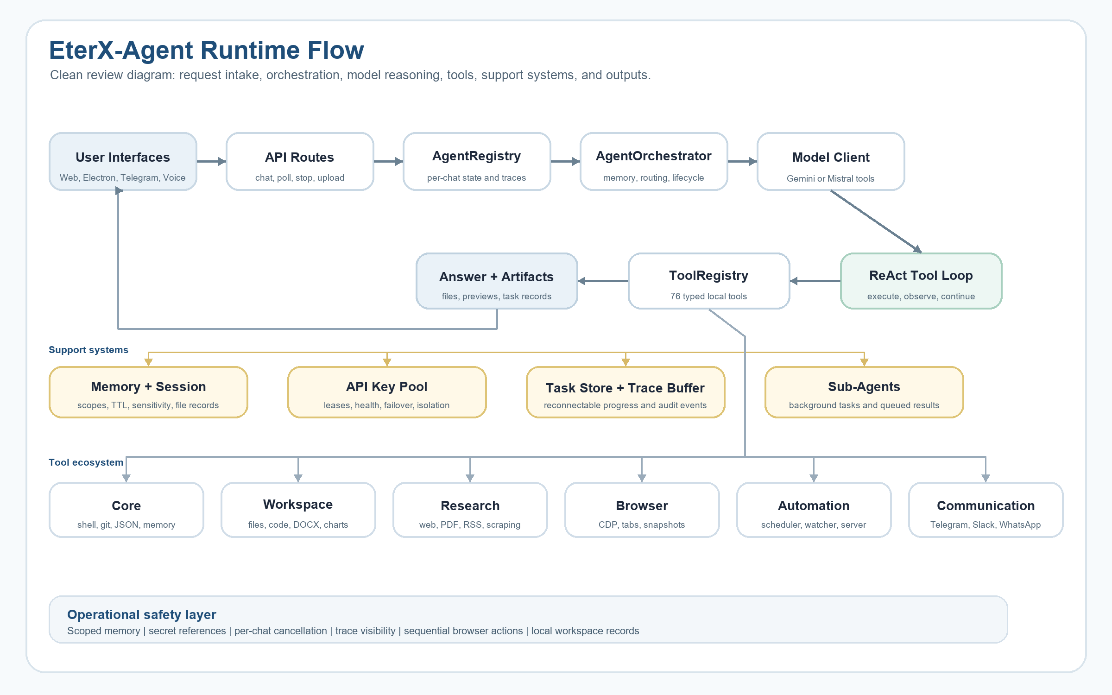
Figure 1. EterX-Agent runtime flow, support systems, tool ecosystem, and operational safety layer.

EterX-Agent Architecture
Core Contribution
EterX-Agent contributes a practical execution layer for agents: per-chat state, reconnectable traces, scoped memory, typed tools, browser sequencing, local artifact records, sub-agent result queues, and API-key leasing.

Per-Chat Agent Registry
The AgentRegistry gives each chat a dedicated execution record containing prompt, status, trace buffer, final answer, cancellation flag, model mode, key lease, and metrics. This makes long-running work independent from a fragile browser connection. A user can refresh the UI and later poll for trace events instead of losing the task.

Orchestrator
The orchestrator initializes memory, session state, and workspace context; records user events; hydrates relevant memory; classifies task complexity; selects a model route; invokes the tool loop; and persists final session records. Its value is coordination, not model intelligence alone.

Model Client and Tool Loop
The model client converts typed tool schemas into model function declarations, executes tools, feeds results back into the conversation, blocks duplicate calls, summarizes tool results, and treats browser actions as sequential. This is where the ordinary ReAct loop becomes a usable local runtime.

Tool Registry
The registry exposes 76 typed tools across core, workspace, research, browser, automation, and communication categories. Each tool has a name, description, schema, output shape, and execution function. This makes tool access explicit and inspectable.

Persistent Memory and Session Continuity
Memory V2 separates scopes such as raw, session, project, user, tool, error, artifact, credential, self_improvement, and eval. Records include confidence, importance, sensitivity, status, provenance, tags, and optional TTL. Credentials are exposed as references rather than raw values.

Parallel Sub-Agents
The sub-agent system runs background work independently. A spawned agent receives a brief, writes status, queues results, and can be collected later. API-key leasing reduces collisions between main work and background agents.

Browser and Desktop Automation
The browser engine supports managed Chromium, CDP connections, persistent profiles, tab reuse, snapshots, downloads, console logs, and dialogs. Browser tools are serialized because page state changes after each action.

User Interfaces
The same execution core supports web UI, Electron desktop, Telegram, and live voice. This is important because continuity must survive not just tool calls but also changes in how the user reaches the agent.

Installer, CLI, and Operational Layer
The setup layer handles dependencies, provider configuration, health checks, desktop shortcuts, launch modes, backups, restore, and diagnostics. This makes the project closer to a deployable system than a single-script prototype.

Original Contributions
The project does not claim to invent planning, memory, tool use, or multi-agent systems. Those are established categories. The originality is in the implementation layer that makes those categories work together in a local, multi-interface runtime.
Contribution | Why it matters
Reconnectable per-chat execution | Long tasks can continue after UI refresh or connection loss, with traces recovered by polling.
Scoped Memory V2 | Memory is organized by purpose and sensitivity, reducing stale-context contamination.
API-key leasing | Parallel agents are treated as runtime workers competing for limited model capacity.
Trace persistence | Tool calls, file previews, shell output, and sub-agent events remain inspectable instead of hidden.
Multi-interface continuity | Web, desktop, Telegram, and voice route into one execution system instead of separate wrappers.
Sequential browser control | Browser actions respect changing page state instead of running as unsafe parallel calls.
Table 3. Project-specific contributions emphasized for technical review.

Failure Examples from Implementation

Failure pressure | Observed risk | Design response
Stale memory contamination | Old preferences or prior task facts can override the current user request. | Memory is scoped, sensitivity-labeled, and treated as context rather than instruction.
Repeated tool calls | The model can search, read, or run the same action repeatedly when results are not summarized. | Tool signatures, result digests, duplicate blocking, and trace feedback reduce loops.
Browser state conflicts | Parallel browser actions can click or read the wrong page state. | Browser control is serialized and based on snapshots/ref IDs.
Reconnect loss | A long task can continue server-side while the UI loses its stream. | Per-chat registry state and polling recover trace events.
Sub-agent/key collision | Background agents can compete with the main chat for the same provider capacity. | API-key leasing gives main chats and sub-agents explicit leases and health tracking.
Table 4. Concrete implementation failures and architectural responses.

Security, Privacy, and Safety Considerations
EterX-Agent is powerful because it can read and write files, run shell commands, automate browsers, create documents, call APIs, and communicate through external channels. Those capabilities require caution. The codebase already includes secret detection, credential references, memory sensitivity labels, per-chat cancellation, bounded traces, and prompt rules that prevent memory from overriding the latest request.
The project should still not be described as fully sandboxed. Local shell access, broad workspace tools, browser sessions, and communication channels need stronger permission boundaries before wider deployment. The next safety step is to enforce policy in code, not only in prompts.

Evaluation Plan
Dimension | Test design | Metrics
Task success | Run coding, research, document, browser, and file tasks. | Completion rate, human grading, artifact correctness.
Tool reliability | Repeat workflows across files, shell, browser, PDFs, and search. | Error rate, retries, duplicate-call blocks, recovery success.
Planning quality | Compare no planner, decomposer, and sub-agent parallelism. | Step completion, latency, unnecessary tool calls.
Memory safety | Inject preferences, stale facts, secrets, and prompt-injection text. | Correct recall, false recall, leakage rate, injection resistance.
Reconnection | Start long task, disconnect UI, reconnect through polling. | Trace recovery, final answer recovery, task loss rate.
Concurrency | Run multiple chats and sub-agents with limited API keys. | Collision count, wait time, failover success.
User experience | Evaluate trace clarity, stopping, and artifact discoverability. | User ratings, confusion events, time-to-result.
Table 5. Evaluation plan for turning the project into a stronger empirical submission.

Discussion
The most important lesson from EterX-Agent is that useful agents are systems, not just prompts. A good model can still fail if the runtime loses state, hides tool outputs, mixes memories, repeats actions, or cannot recover after disconnection. The strongest engineering signal in the project is therefore the work around continuity, isolation, and observability.
The project also shows a tension in agent design. More tools make the agent more capable, but they also increase risk. Memory improves continuity, but stale memory can corrupt new requests. Parallel agents improve throughput, but they require isolation and resource management. These tradeoffs are exactly why the project is stronger as a systems paper than as a simple application writeup.

Conclusion
EterX-Agent is best understood as serious independent systems work on practical AI-agent reliability. Its value is not that it uses familiar agent categories, but that it implements the layer those categories need in practice: persistent execution, scoped memory, typed tools, observable traces, browser control, sub-agent isolation, multi-interface continuity, and API-key leasing.
For an application supplement, the paper demonstrates technical maturity and builder judgment. It shows a real system, the failures that shaped it, the architecture used to respond, and the limits that still need evaluation. The next step is a formal benchmark suite, but the current document already provides strong evidence of sustained systems thinking.

Implementation Evidence
This appendix summarizes the local implementation evidence used to write the paper.
Evidence | File
Task lifecycle, complexity routing, memory hydration, execution persistence | src/lib/agent/orchestrator.ts
Tool loop, schema conversion, retry/survivor state, deduplication, trace events | src/lib/agent/gemini.ts
Per-chat execution, trace buffer, polling recovery, visual memory, key leasing | src/lib/agent/agent-registry.ts
API-key leasing, health tracking, failover, sub-agent key isolation | src/lib/agent/api-key-pool.ts
Scoped Memory V2, sensitivity labels, secret refs, credential encryption | src/lib/agent/memory/v2.ts
Session continuity, file records, tool digest, self-review | src/lib/agent/session.ts
Fire-and-forget sub-agents and pending result queue | src/lib/agent/roles/sub_agent.ts
Tool registry and bootstrap | src/lib/agent/tools/registry.ts, src/lib/agent/tools/index.ts
Browser CDP and Playwright engine | src/lib/agent/browser/engine.ts
Telegram bridge | telegram-bot.ts
Live voice client | src/lib/live/gemini-live.ts
Desktop shell | electron/main.js
CLI and setup | eterx.js, setup.js, setup/**
Table 6. Implementation evidence and source locations.

